**Project Title**

**Finance KPI Dashboard Using Excel and Power BI**

**Submitted By: Submission Date:**28/07/2025

Name: Yadav Manish Hukumdev

**Table of Contents:**

1. Project Overview

2.Tools and Technologies Used

3. Methodology

4. Problems & Challenges

5. Solution & Strategies

6. Page 1: Overall KPI Analysis

7. Page 2: Salesperson Performance Analysis

8. Insights & Recommendations

9. Conclusion

**Project Overview:**

This report analyses sales performance using a dataset sourced from Kaggle. The data was cleaned and prepared using Excel before visualizing it in the Finance KPI Dashboard. It highlights key metrics, trends, and provides actionable recommendations.

**Tools and Technologies Used:**

**Microsoft Excel:**

For data cleaning, removing duplicates, fixing date formats, and preparing the dataset.

**Kaggle:**

Source of the raw sales data.

**Power BI:**

For creating interactive dashboards, charts, and visual reports to analyse sales trends and performance.

**DAX (Data Analysis Expressions):**

Used inside Power BI to calculate measures like variance, variance %, YTD Variance %, Avg Sales Actual, Avg Sales Target, Sales Target Achieved etc.

**Methodology:**

**Data Collection:** The sales dataset was collected from Kaggle.

**Data Cleaning:**

Cleaned the raw data in Microsoft Excel by removing duplicate records, fixing inconsistent date formats, and handling missing values.

**Data Preparation:**

Created new columns for calculations like variance, target achievement, and monthly summaries.

**Data Visualisation:**

Imported the cleaned data into Power BI to design interactive dashboards and charts.

**Analysis:**

Analysed sales trends, target vs. actual performance, monthly patterns, and individual salesperson performance using various visuals like bar charts, waterfall charts, pie charts, and scatter plots.

**Problems & Challenges:**

* The original Kaggle dataset had duplicate records and missing or inconsistent values.
* Dates were in mixed formats, making it difficult to create clear time-based charts.
* Combining multiple views (monthly trends, individual performance, target gaps) into one clear dashboard was time-consuming.

**Solutions & Strategies:**

* Cleaned the raw data in Excel by removing duplicates, fixing date formats, and filling missing fields where possible.
* Used Power BI to build clear charts like waterfall, leaderboard, pie, and scatter plots.
* Highlighted key gaps visually to help managers easily spot weak months and low performing salespeople.
* Suggested practical actions like closer monitoring of underperformers, better target planning, and individual coaching to balance team performance.

**Page 1: Overall KPI Analysis**

Key Metrics:

|  |  |  |
| --- | --- | --- |
| **KPI** | **VALUE** | **YTD** |
| Total Sales Actual | $19M | $2M |
| Total Sales Target | $19M | $3M |
| Variance | $367K | $113K |
| Variance % | -1.9% | -4.4% |
| Months Target Reached | 2/14 | — |

**Total Sales Actual:**

This shows the total sales revenue achieved so far.

Example: ₹ 19,014,387

**Total Sales Target:**

This shows the planned target for the same period.

Example: ₹ 19,381,500

**Variance (₹):**

This shows the difference between actual sales and the target in currency value.

Example: –₹ 367,113 (negative means sales are slightly below target)

**Variance (%):**

This shows the difference as a percentage.

Example: –1.9%

**What these numbers mean:**

At first glance, the company looks quite close to its goal — the total sales are about 98% of the target. However, the slight shortfall hints that there may be specific months or teams that need attention.

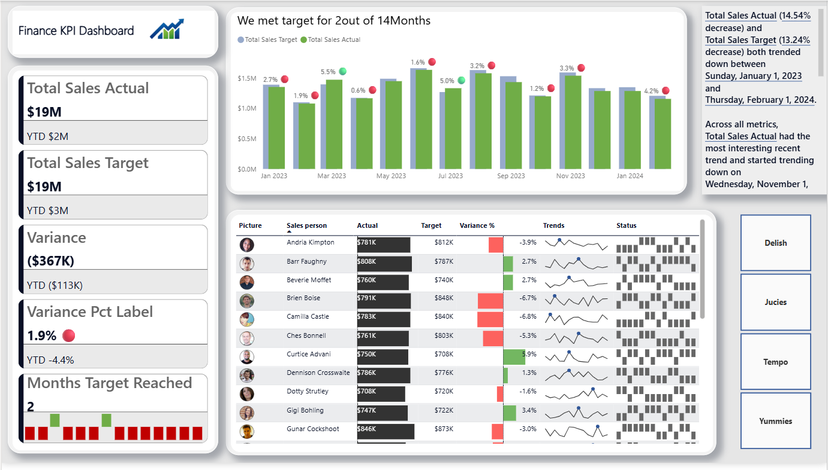

**Description:**

Provides a clear, high-level view of the company’s overall sales performance for the year. It shows how much sales the team actually achieved, what the target was, and where the gaps are month by month. This page helps anyone whether it’s management, a client, or a stakeholder quickly understand whether the sales goals are being met or missed

**Page 2: Sales Person Performance:**

**Metrics:**

|  |  |
| --- | --- |
| **KPI** | **VALUE** |
| Avg Sales Actual | 54.14K |
| Avg Sales Target | 55.19K |
| Target Achieved | 96% |

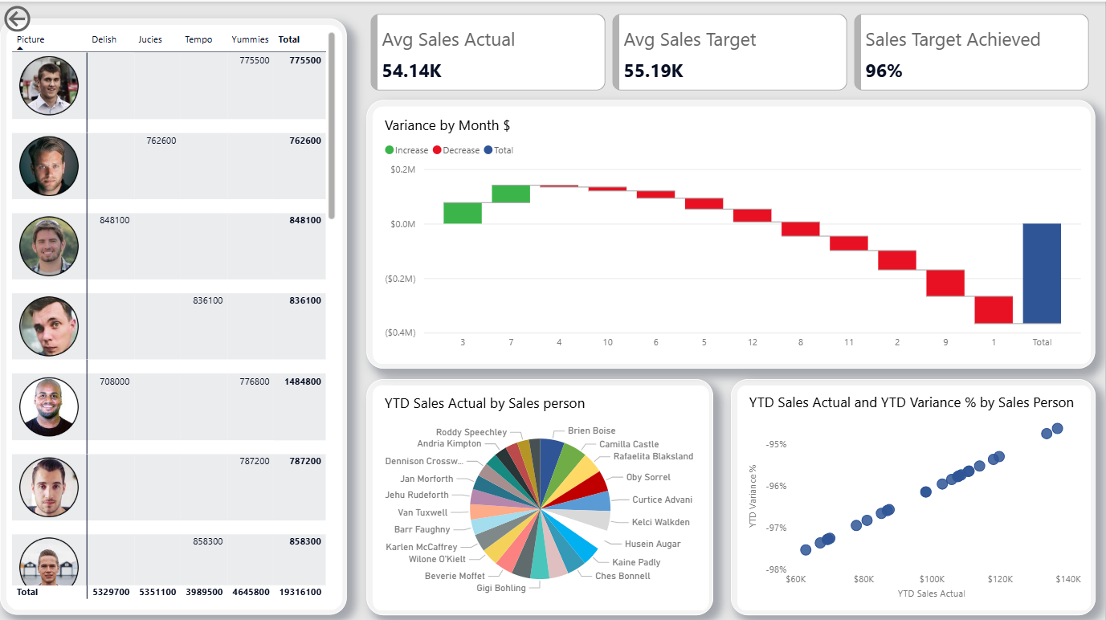**What These Metrics Mean:**  
“Our average actual sales are slightly lower than what we planned for each month. We aim for ₹ 55.19k but we reach about ₹ 54.14k on average. This means we’re hitting 96% of our target which is decent, but there’s still a small shortfall every month that adds up over the year. If we can improve by even a small amount just 4%more we can fully meet or exceed our sales target.”

**Description:**

shows how each salesperson is adding to total sales and where performance gaps still exist. It highlights who is performing well and who is falling behind. The leaderboard ranks salespeople by total sales, making it clear who brings in the most revenue. The waterfall chart shows which months helped cover losses and which months pulled sales down. The pie chart shows each person’s share of yearly sales, revealing if the company depends too much on just a few people. Finally, the scatter chart compares each salesperson’s sales to how well they meet their targets. Together, these visuals clearly show who drives results, where support is needed, and what can be improved to balance performance across the team.

**Key Insights:**

* Good: High average target achievement (around 96%) shows solid sales pipeline.
* Weak: Poor consistency — only 2 months met target.
* Risk: Heavy dependency on few top salespeople.
* Gap: Several months show large negative variance.

**Recommendations:**

* Deep dive high shortfall months for specific causes.
* Rebalance targets for top & bottom reps if needed.
* Design training for consistent average performers.
* Keep monthly variance tracking in dashboards.
* Continue data cleaning SOP for reliable reports.

**Conclusion:**

The Finance KPI Dashboard, built with Kaggle data & cleaned in Excel, reveals that while annual performance is near target, month-wise inconsistency and individual contribution imbalance require immediate attention. Regular monitoring, training, and realistic goal setting can ensure sustained sales success.